Atharva Yadav

S23-127

Network Lab

NETWORK LAB ASSIGNMENT NO.5 A

AIM : SIMULATION OF NETWORK WITH SPECIFIC ROUTING : DISTANCE ROUTING

Distant vector routing protocol also called as Bellman-Ford algorithm or Ford Fulkerson algorithm used to calculate a path. A distance-vector protocol calculates the distance and direction of the vector of the next hop from the information obtained by the neighboring router

CODE:

set ns [new Simulator] set nf [open out.nam w] $ns namtrace-all $nf set tr [open out.tr w] $ns trace-all $tr proc finish {} { global nf ns tr $ns flush-trace close $tr exec nam out.nam & exit 0 }

set n0 [$ns node] set n1 [$ns node] set n2 [$ns node] set n3 [$ns node]

$ns duplex-link $n0 $n1 10Mb 10ms DropTail

$ns duplex-link $n1 $n3 10Mb 10ms DropTail

$ns duplex-link $n2 $n1 10Mb 10ms DropTail

$ns duplex-link-op $n0 $n1 orient right-down

$ns duplex-link-op $n1 $n3 orient right $ns duplex-link-op $n2 $n1 orient right-up set tcp [new Agent/TCP] $ns attach-agent $n0 $tcp set ftp [new Application/FTP] $ftp attach-agent $tcp set sink [new Agent/TCPSink] $ns attach-agent $n3 $sink set udp [new Agent/UDP] $ns attach-agent $n2 $udp

set cbr [new Application/Traffic/CBR]

$cbr attach-agent $udp set null [new Agent/Null] $ns attach-agent $n3 $null

$ns connect $tcp $sink

$ns connect $udp $null

$ns rtmodel-at 1.0 down $n1 $n3

$ns rtmodel-at 2.0 up $n1 $n3

$ns rtproto DV

$ns at 0.0 "$ftp start"

$ns at 0.0 "$cbr start"

$ns at 5.0 "finish"

$ns run

OUTPUT:

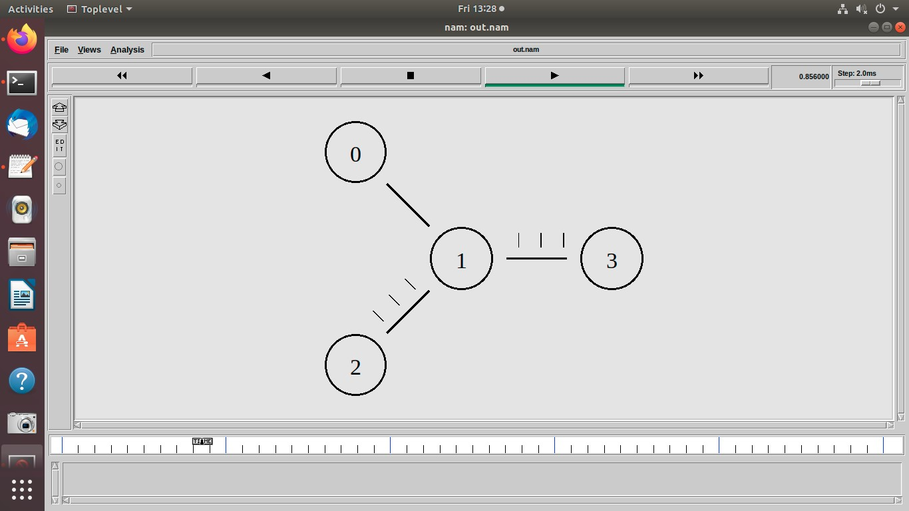

Conclusions: Distance vector protocols like RIP are simple to implement and suitable for small to medium-sized networks with low traffic. However, their slow convergence and susceptibility to routing loops make them less suitable for large, dynamic networks. Consider network size, traffic patterns, and reliability requirements when selecting a routing protocol.

BASED ON LO4 : To implement client-server socket programs.